Player Position Card – 4-4-2

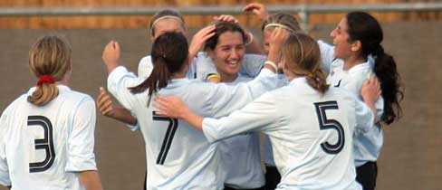
- 10

11 4 8 7

3 6 5 2

1

4-4-2

Roles & Responsibilities of Number 11 (Right Winger)

No. 11 – Left Winger

- When We Have Possession; Play High Up The Pitch On Opposition Right Back & Threaten Space Behind Her By Anticipating Balls Behind

- If 1. Doesn’t Occur, Check Short For Ball To Feet And Either Look For Quick One-Two Or Dribble At Defence

- Cross/Pass Early With Pace And Precision

- When Crosses Are Delivered From Right; Lock Off Back Post To Prevent Ball Passing Across Face of Goal

- Track Opposition Right Back On All Forward Runs She Makes

